1: write a program to print arithmetic series 1 4 7 10

Program:

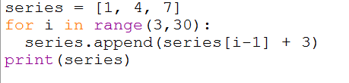

output:



2 : write a program to find the sum of series 1^3 2^3 3^3 ………

Program:

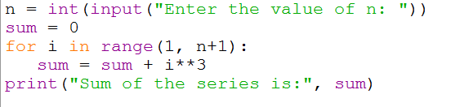

Output:

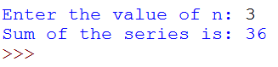

3:half pyramid pattern of numbers

Program:

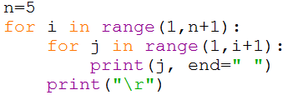

Output:

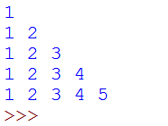

4: downward half pyramid pattern of star

Program:

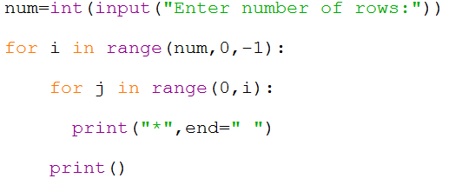

|  |  |  |  |  |  |
| --- | --- | --- | --- | --- | --- |
| |  | | --- | |  | |  | |  |  | https://mail.google.com/mail/u/0/images/cleardot.gif  https://mail.google.com/mail/u/0/images/cleardot.gif |
| Output: | | |
|  | | |  |

5: binary to decimal

Program:

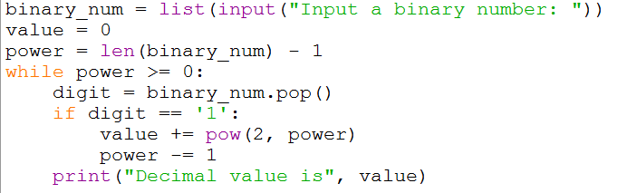

Output:

